**Assignment – 4**

Name- Yashraj Ranjeet Shitole

Roll no. - 86633

1) Write a select command that produces the order number, amount, and date for all rows in the Orders table.

**SELECT Onum, Amt, Odate from Orders;**

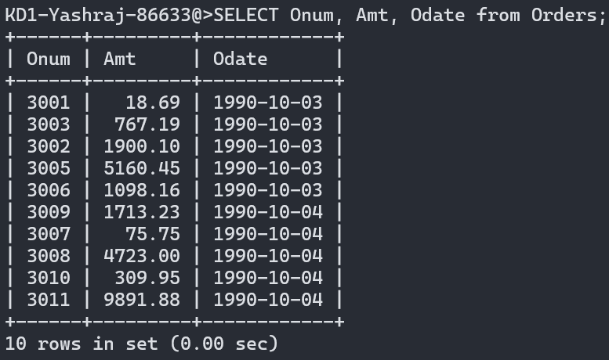

2) Write a query that produces all rows from the Customers table for which the salesperson’s number is 1001.

**SELECT * FROM Customers WHERE Snum = 1001;**

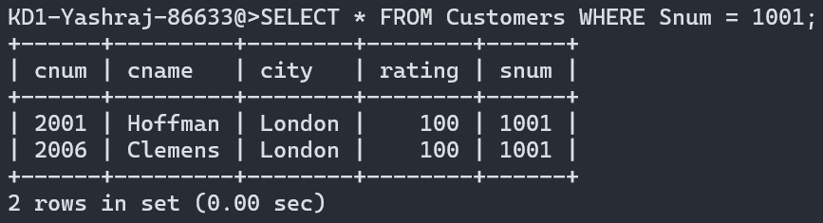

3) Write a query that displays the Salespeople table with the columns in the following order: city, sname, snum, comm.

**SELECT city, sname, snum, comm from Salespeople;**

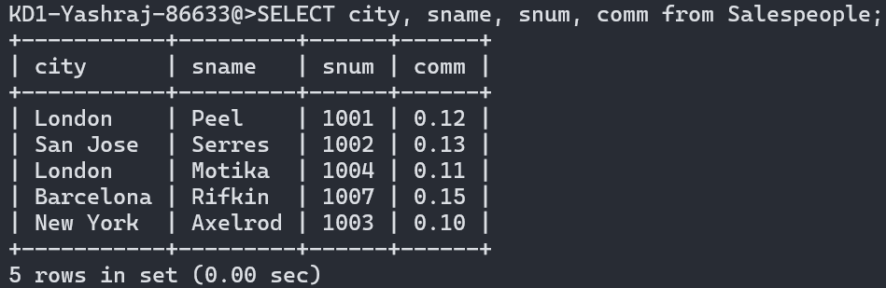

4) Write a select command that produces the rating followed by the name of each customer in San Jose.

**SELECT rating, Cname FROM Customers WHERE city= ‘San Jose’;**

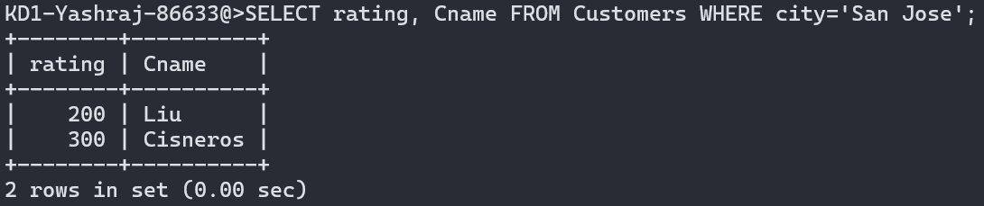

5) Write a query that will produce the snum values of all salespeople (suppress the duplicates) with orders in the Orders table.

**SELECT DISTINCT Snum FROM Orders;**

